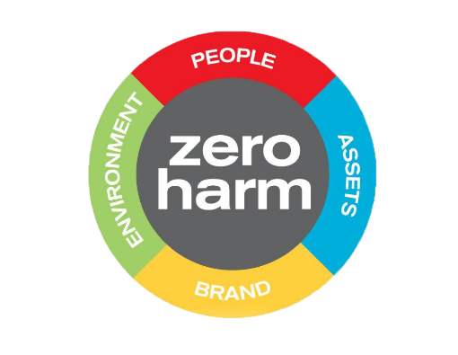
Hazardous Substances Register

Fieldays has a zero-harm policy and the safety of our exhibitors and visitors is of the utmost importance to us.
Please list all hazardous substances you will be bringing to Fieldays and include all information listed in the Hazardous Substances Inventory (below) along with Safety Data Sheets for each substance listed.
Company Name: Click or tap here to enter Company Name. Site Number: Click or tap here to enter Site Number.

Name of Product | Approval Number & Group Standard name  (if Applicable) | Hazard classification (UN class and packing group) | Current SDS available? | Specific storage and segregation requirements | Container size | Open or closed container? | Gas, Liquid or solid | Location on site (eg lockable container/cabinet) | Maximum likely amount
Click here. | Click here. | Click here. | Select | Click here. | Click here. | Select | Click here. | Click here. | Click here.
Click here. | Click here. | Click here. | Select | Click here. | Click here. | Select | Click here. | Click here. | Click here.
Click here. | Click here. | Click here. | Select | Click here. | Click here. | Select | Click here. | Click here. | Click here.
Click here. | Click here. | Click here. | Select | Click here. | Click here. | Select | Click here. | Click here. | Click here.
Click here. | Click here. | Click here. | Select | Click here. | Click here. | Select | Click here. | Click here. | Click here.
Click here. | Click here. | Click here. | Select | Click here. | Click here. | Select | Click here. | Click here. | Click here.

